Health Promotion: Healthy Eating Activities Evaluation
- Pre-Assessment: 90% of the clients have correctly identified pictures of grains, dairy, proteins, fruits and vegetables.
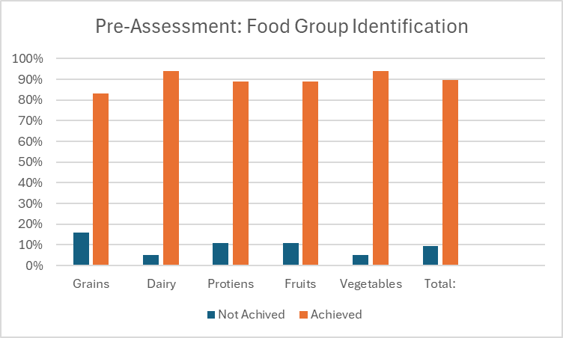

- Activity 1: Build A Healthy Plate
There were only 18 participants available due to doctor appointments, scheduled outings, and declined participants. The participants successfully built their healthy lunch/dinner plates using a MyPlate and pictures of grains, dairy, proteins, fruits and vegetables, with the assistance of Day Activity staff. The key message that was repeated to the clients was to eat fruits and vegetables everyday and drink water.
- Activity 2: Group Sharing Discussion
Each participant was asked to share what they had on their plates and why they made those choices. Some hesitancy was observed among the clients to share what they had. Other participants were excited to discuss what they had and even made their favorite meals – spaghetti dinner, cheeseburgers, etc. The key message here was to try new foods when you can.

- Activity 3: Food Group Sorting Game
On this day, there were 21 participants. In groups of three, participants had to work together to correctly sort pictures of food that was spread out on the table before them into the five bins labeled “grains,” “dairy,” “proteins,” “fruits,” and “vegetables.” On average, 42% of the food pictures were sorted correctly into their corresponding bins and 19% were incorrectly sorted.
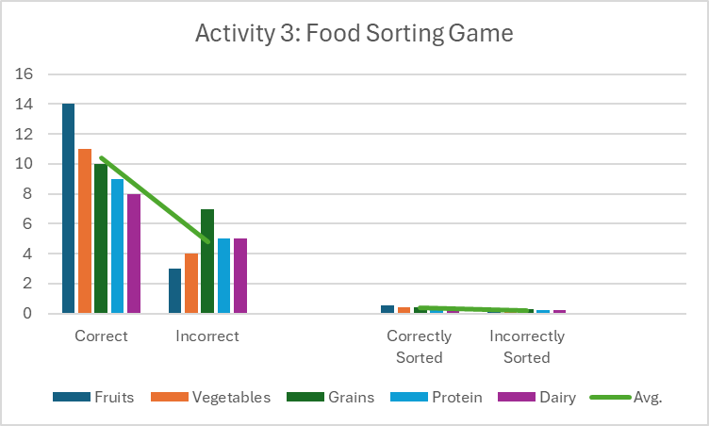
- Activity 4: Taste Testing Healthy Snacks
In groups of three, each participant had 6 different snack cups prepped with a variety of healthy snacks that they can taste and rate whether they like it, its okay, or don’t like it.
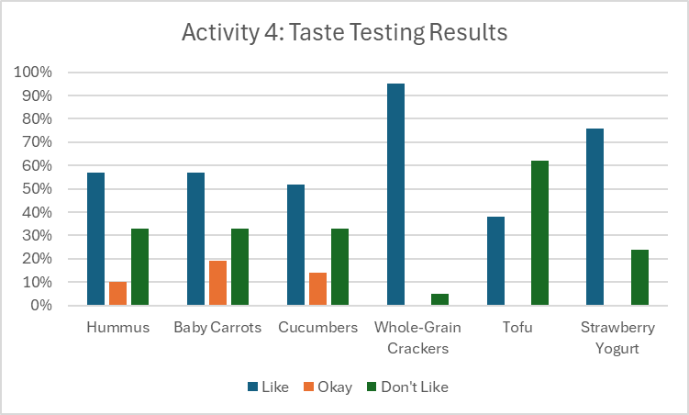

- Post-Assessment: 94% of the clients have correctly identified pictures of grains, dairy, proteins, fruits and vegetables.
